**Zach Haynes– Young Climate Activist, UK**

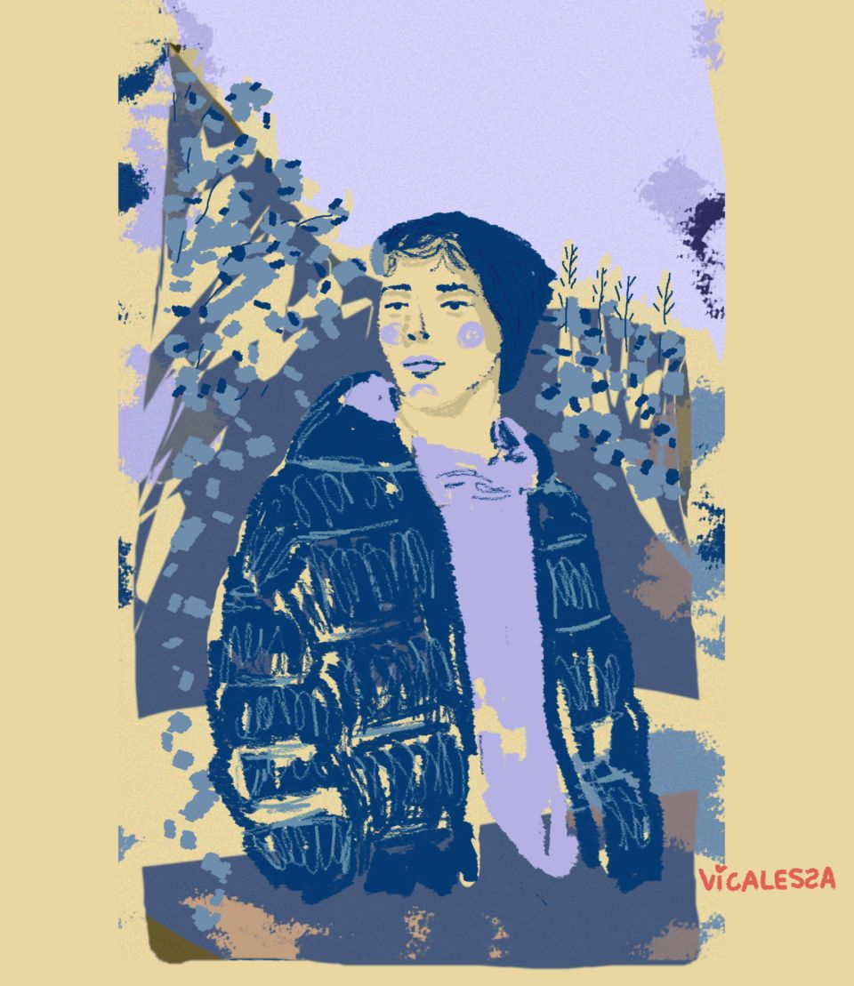Realising I am one of few young people who cares about wildlife and the environment inspires me to take social action.

Modern day life disconnects people from nature and unless they enjoy and care about it they will not look after it.

I started blogging and using social media aged 10 to share my love of nature and inspire others to care for it. This led to me meeting lots of people and volunteering to help at nature reserves, with conservation tasks such as bird-ringing, and take part in projects to understand what is happening to local wildlife. I also fundraise for local and national charities. I do social action with lots of organisations including Yorkshire Wildlife Trust and independently. I also write to my local MP and the Prime Minister on these issues. I have also written articles, given radio interviews and talks and contribute to workshops around how nature organisations can better engage young people.

“I will … do my best to promote the importance of the environment and encourage and inspire more young people to realise they can, and need to, make a positive contribution to the world around us.”

My peers don’t always support my work as they don’t love nature. But I have found support on social media and learnt that by joining up with others we can make a big difference.

**“It doesn’t matter what age you are, you can make more than a little difference.”**

(Adapted from iwill.org.uk)